[**INFO6210**](https://northeastern.blackboard.com/webapps/blackboard/execute/launcher?type=Course&id=_2565130_1&url=)**: DATA MANAGEMENT AND DATABASE DESIGN**

**PROJECT TITLE: HOSPITAL MANAGEMENT SYSTEM**

**By**

**Ajay Mohandas**

**NEU ID: 001426741**

Date: 12th December, 2018

Contents

**PROBLEM STATEMENT AND ITS SCOPE** 2

**Business Rules** 4

**Entity Relationship Model** 6

**SCREENSHOTS** 7

**Notes** 13

**Appendix** 14

**References** 34

# **PROBLEM STATEMENT AND ITS SCOPE**

Hospital currently uses a manual system for management and maintenance of critical information. The current system stores patient records in paper form and it is difficult to retrieve such information when needed. Most of the details are stored in paper format, also are inconsistent and redundant. The medicines prescribed by doctor and the location of its storage becomes difficult if they are not stored properly. Contacting the right supplier for the medicines becomes a tedious job when right information are not stored in the system. Few a time’s checking availability of the doctor is also important for taking appointments. When system does not store such details then receptionist would find problem while booking appointments for the patient.

By creating a database system for the hospital we will be able to store data in the right tables and will be able to retrieve faster than traditional systems. Storing patient historical records and current records will help analyse patient status. Setting up list of supplier will help us in contacting the right supplier for the right medicines when they are at shortage. Doctor’s availability will help us get information on when to set up appointments for the patients. Normalizing and standardizing the data would help remove redundant and inconsistent data from the system.

**The system maintains below user level**:

1. Administrator
2. Patient
3. Nurse
4. Doctor
5. Staff

**The system includes below details**:

1. Maintaining patient, doctor, supplier records
2. Checking availability of doctor for appointments
3. Checking availability of medicines

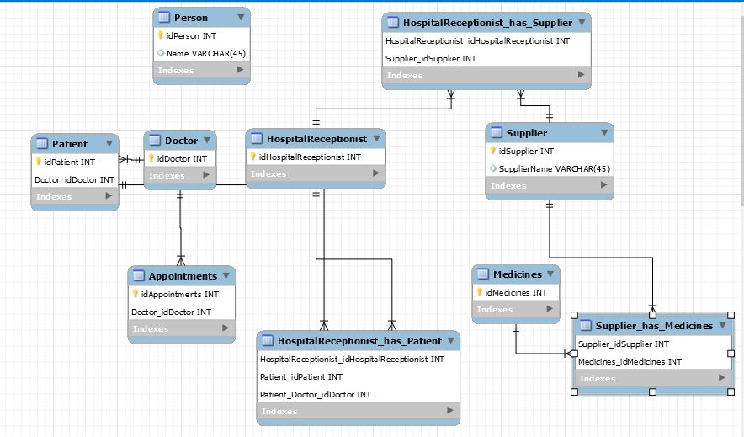

**Use Case Diagram**:

Patient Staff

Supplier

Doctor

# **Business Rules**

1. The goal is to store details pertaining to a hospital in a relational database. Following are the entities involved in the model:
2. Department
3. Administrator
4. Staff
5. Doctor
6. Nurse
7. Patient
8. Address_details
9. Contact_details
10. Patient current Records
11. Patient Medical History
12. Patient Bill
13. Supplier
14. Manufacturer
15. Medicine
16. Room
17. OrderDetail
18. Relations between entities
19. Each department must have one admin and every admin is assigned to one department itself🡪one to one
20. Admin, Staff, Doctor, Nurse ,Patient, Supplier, Manufacture will have one or more than one address and contact details. Each address or contact will have one admin, , Staff, Doctor, Patient, Supplier, Manufacture🡪 one to many
21. Each department will have one or more patient, nurse, room and doctor, staff. But each doctor, nurse, room and patient is assigned to only one department🡪one to many
22. Each patient is assigned to one room and each room has only one or no patient🡪one to one
23. Each patient has one doctor assigned to him/her but a doctor may or may not many patients🡪 one to many
24. Each nurse may or may not have many patient assigned but each patient has one nurse🡪 one to many
25. A doctor will have one or more current patient records and each current patient records will have at least one doctor🡪many to many
26. Each patient has one current patient records and each patient record has one patient itself🡪one to one
27. A doctor will have one or more patient history records and each patient history records will have at least one doctor🡪many to many
28. Each patient has one patient history records and each patient record has one patient itself🡪one to one
29. Each patient has a bill to be paid and each bill is assigned to one patient🡪one to one
30. A patient is given one or more medicine and vice versa but optional🡪many to many
31. An department will have one or more supplier and manufacturer and vice versa🡪many to many

# **Entity Relationship Model**

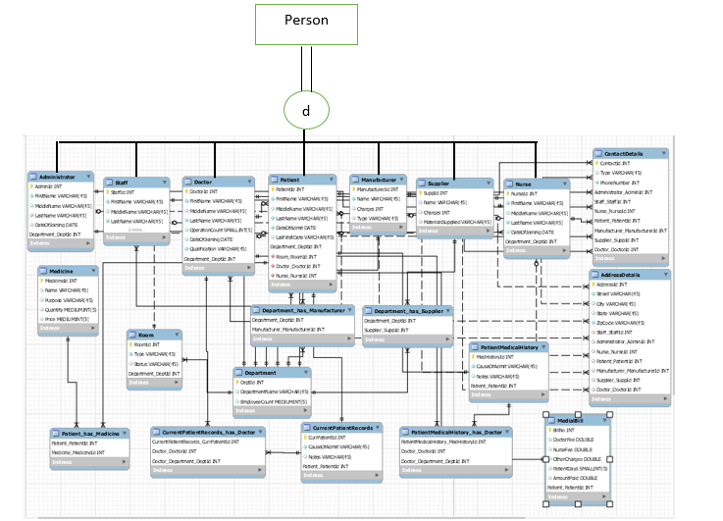

Below are the measures taken to normalize the tables in the database:

1. Person table had “Address detail” as an attribute. This violates the 1NF since in 1NF we cannot have multivalued attributes. Also we cannot have repeating groups of attributes like Address1, Address2, and Address3.
2. In order to remove these anomalies a separate table “Address Detail” is created which includes foreign key of staff, administrator, doctor, nurse, manufacturer, patient and supplier.
3. Point 1 and 2 has been followed for “Contact detail” table.
4. The “Patient” table had patient records which depended on “PatientId” and “RecordId” which violates the 2NF rule where partial dependency is present since attributes such as “Notes”, “Records are depended on RecordId”. To remove this dependency “Patient” table was normalized to “Patient”, “CurrentPatientRecords” and “PatientMedicalHistory” which tracks patient details in three different tables.
5. “Supplier” table had attributes like SuppId, Name, Charges, MaterialsSupplier, MedicineId, MedicineName. MedicineName depended on MedicineId which depends on primary key SuppId. This violates 3NF rule. In order to bring the table to 3NF “Supplier” table is created with SuppId, Name, Charges and MaterialSupplied and “OrderDetails” table contains column like OrderId, MedicineName, SupplierId and SupplierName.

# **SCREENSHOTS**

1. Forward Engineering completed and created the scheme with respect to ER model

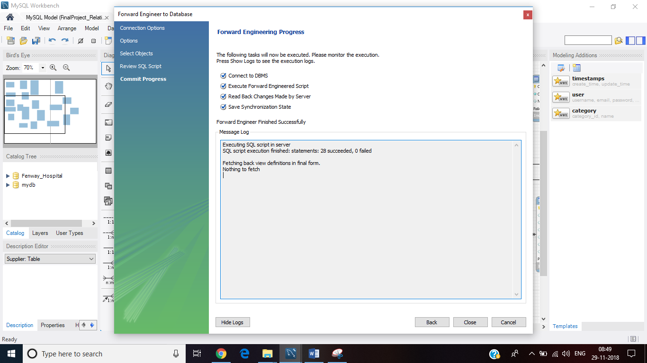

1. Indexes
2. create index room_index on room(Status) using BTREE;

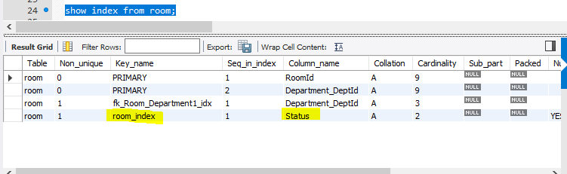

1. create index medicine_index on Medicine(Quantity) using BTREE;

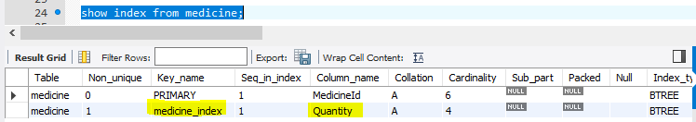

1. Views and Joins
2. create view Patient_Records

as

select Patient.PatientId,Concat(Patient.FirstName,' ',Patient.MiddleName,' ',Patient.LastName) As PatientName, currmed.CauseOfAdmit, currmed.Notes, medhistory.HistoryRecords, medhistory.HistoryNotes

from Patient JOIN

CurrentPatientRecords currmed

ON Patient.PatientId = currmed.Patient_PatientId JOIN

PatientMedicalHistory medhistory

ON Patient.PatientId = medhistory.Patient_PatientId;

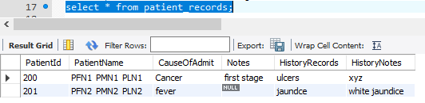

Analysis: This view has been granted to Doctor, Patient and Staff and Nurse. Authorized users will be able to view patient details, current patient records and also his/her medical history.

1. Create view PatientBill AS

select bill.BillNo,P.PatientId,Concat(P.FirstName,' ',P.MiddleName,' ',P.LastName) As PatientName,

currmed.CauseOfAdmit, D.DoctorId,Concat(D.FirstName,' ',D.MiddleName,' ',D.LastName) As DoctorName,

**((bill.DoctorFee + bill.NurseFee + bill.OtherCharges) - bill.AmountPaid) As 'Total Bill'**

from Patient P

JOIN CurrentPatientRecords currmed

ON P.PatientId = currmed.Patient_PatientId

JOIN MedialBill bill

ON P.PatientId = bill.Patient_PatientId

JOIN Doctor D

ON P.Doctor_DoctorId = D.DoctorId;

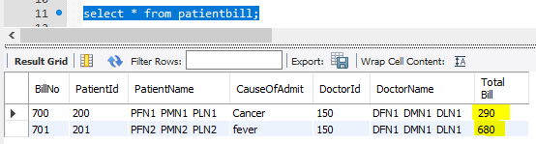

Analysis: This view has been granted to Patient and Staff. The value in “Total Bill” column is a calculated by adding Doctor fee, nurse fee and other charges that hospital may charge and that sum is subtracted if patient has paid some amount as highlighted in green in the code.

1. Triggers:
2. Delimiter $$

create trigger Room_Records

After update

on Fenway_Hospital.patient

for each row

Begin

set @oldRoomId = OLD.Room_RoomId;

set @newRoomId = NEW.Room_RoomId;

update Fenway_Hospital.room set room.status = 'O'

where room.RoomId = @newRoomId;

update Fenway_Hospital.room set room.status = 'V'

where room.RoomId = @oldRoomId;

END;

$$

Step1: Before updating patient records the status of room id 500 is V i.e vacant

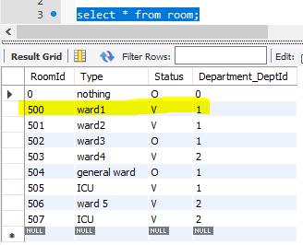

Step2: UPDATE `fenway_hospital`.`patient` SET `Department_DeptId` = '1', `Room_RoomId` = '500' WHERE (`PatientId` = '203') and (`Department_DeptId` = '2');

Step3: Room_Records triiger has been triggered and RoomId 500 status has been changed to O i.e Occupied

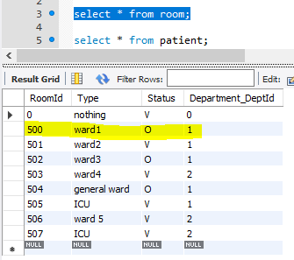

1. create trigger Medicine_Quantity

After update

on Fenway_Hospital.patient_has_medicine

for each row

Begin

set @newMedId = NEW.Medicine_MedicineId;

update Fenway_Hospital.medicine set Quantity = Quantity - 1

where medicine.MedicineId = @newMedId;

END;

$$

Step1: The quantity of Medicneid 251 is 2 before trigger event

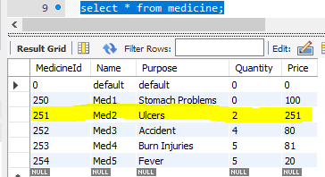

Step2:

UPDATE `fenway_hospital`.`patient_has_medicine` SET `Medicine_MedicineId` = '251' WHERE (`Patient_PatientId` = '204') and (`Medicine_MedicineId` = '0');

UPDATE `fenway_hospital`.`patient_has_medicine` SET `Medicine_MedicineId` = '251' WHERE (`Patient_PatientId` = '203') and (`Medicine_MedicineId` = '0');

Step3: After triggering event the quantity of medicine id 251 is

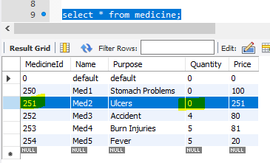

After updating of Patient_has_medicine the unit is decremented by 1.

1. Procerdure

DELIMITER $$

CREATE PROCEDURE OrderMedicine(IN MedicineName varchar(45))

BEGIN

declare MedQuantity int;

declare MedId int;

declare MedName varchar(45);

declare SupplierId int;

declare SuppName varchar(45);

set MedName = MedicineName;

select MedicineId into MedId from Medicine where Medicine.Name = MedName;

select Quantity into MedQuantity from Medicine where Medicine.Name = MedName AND MedicineId = MedId;

select SuppId into SupplierId from Supplier_Supplies_Medicine where MedicineId = MedId;

select Supplier.Name into SuppName from supplier where SuppId = SupplierId;

insert into OrderDetail (MedicineId,MedicineName,SupplierId,SupplierName)

select MedId, MedName, SupplierId, SuppName

where MedQuantity = 0;

select * from OrderDetail;

END;

$$

call OrderMedicine('Med3');

Before calling procedures:

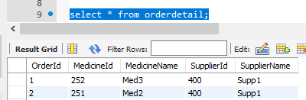

After calling procedures:

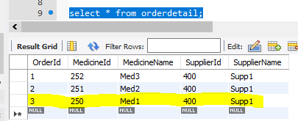

1. Privileges

create user 'doctor1'@localhost identified by 'doctor1';

Grant select on patient_records to 'doctor1'@localhost;

create user 'Hospital_Admin'@localhost identified by 'admin';

Grant all privileges on fenway_hospital.* to 'Hospital_Admin'@localhost;

create user 'Patient'@localhost identified by 'patient';

Grant select on patient_records to 'Patient'@localhost;

Grant select on patientbill to 'Patient'@localhost;

grant select on Vacant_Rooms to 'Patient'@localhost;

Grant insert on patient to 'Patient'@localhost;

Grant update on patient to 'Patient'@localhost;

create user 'Staff'@localhost identified by 'staff';

Grant select on patient_records to 'Staff'@localhost;

Grant select on patientbill to 'Staff'@localhost;

GRANT EXECUTE ON PROCEDURE OrderMedicine TO 'Staff'@localhost;

Grant insert on staff to 'Staff'@localhost;

Grant update on staff to 'Staff'@localhost;

create user 'Supplier'@localhost identified by 'supplier';

Grant select on orderdetail to 'Supplier'@localhost;

create user ‘Nurse’@localhost identified by nurse;

Grant select on medialbill to ‘Nurse’@localhost;

Grant select on patient_records to ‘Nurse’@localhost;

Grant insert on nurse to ‘Nurse’@localhost;

Grant update on nurse to ‘Nurse’@localhost;

Grant select on medicine to ‘Nurse’@localhost;

1. DELIMITER //

Create Function Total_Vacant_Rooms(deptid int)

Returns INT

DETERMINISTIC

Begin

declare RoomNumber int;

select count(RoomId) into RoomNumber from room where

RoomId not in (0) and status = 'V' and Department_DeptId = deptid;

return RoomNumber;

END;

//

set @deptNumber = 2;

select DeptId,DepartmentName,EmployeeCount, Total_Vacant_Rooms(@deptNumber) As 'Total vacant rooms in the department' from department where DeptId = @deptNumber;

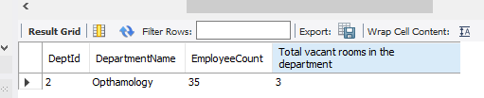

# **Notes**

1. Values inserted in “OrderDetail” table is through stored procedure to give a notification to supplier regarding medicines that have quantity below permissible limit.
2. Have used indexes on Room.Status and Medicine.Quantity since these two columns are heavily used in triggers and procedures too. It will help in fast retrieval of data.
3. Have used mediumint as data type for EmployeeCount in Department table, small int as data type for OperationCount in Doctor table taking number of successful operation done by doctor
4. Have implemented read committed level of isolation layer for transaction where if more than one user wants to book for a room, the data will be committed and new value will be viewed by other user.

**SET TRANSACTION ISOLATION LEVEL read committed;**

**SET SQL_SAFE_UPDATES = 0;**

**START TRANSACTION;**

**update patient set Room_RoomId = '501' where PatientId = '100';**

**DO SLEEP(10);**

**Commit;**

1. Users have been created and granted them privileges according to their work.

# **Appendix**

CREATE DATABASE IF NOT EXISTS `fenway_hospital` /*!40100 DEFAULT CHARACTER SET utf8mb4 COLLATE utf8mb4_0900_ai_ci */;

USE `fenway_hospital`;

-- MySQL dump 10.13 Distrib 8.0.12, for Win64 (x86_64)

--

-- Host: localhost Database: fenway_hospital

-- ------------------------------------------------------

-- Server version 8.0.12

/*!40101 SET @OLD_CHARACTER_SET_CLIENT=@@CHARACTER_SET_CLIENT */;

/*!40101 SET @OLD_CHARACTER_SET_RESULTS=@@CHARACTER_SET_RESULTS */;

/*!40101 SET @OLD_COLLATION_CONNECTION=@@COLLATION_CONNECTION */;

SET NAMES utf8 ;

/*!40103 SET @OLD_TIME_ZONE=@@TIME_ZONE */;

/*!40103 SET TIME_ZONE='+00:00' */;

/*!40014 SET @OLD_UNIQUE_CHECKS=@@UNIQUE_CHECKS, UNIQUE_CHECKS=0 */;

/*!40014 SET @OLD_FOREIGN_KEY_CHECKS=@@FOREIGN_KEY_CHECKS, FOREIGN_KEY_CHECKS=0 */;

/*!40101 SET @OLD_SQL_MODE=@@SQL_MODE, SQL_MODE='NO_AUTO_VALUE_ON_ZERO' */;

/*!40111 SET @OLD_SQL_NOTES=@@SQL_NOTES, SQL_NOTES=0 */;

--

-- Table structure for table `addressdetails`

--

DROP TABLE IF EXISTS `addressdetails`;

/*!40101 SET @saved_cs_client = @@character_set_client */;

SET character_set_client = utf8mb4 ;

CREATE TABLE `addressdetails` (

`AddressId` char(5) NOT NULL,

`Street` varchar(45) NOT NULL,

`City` varchar(45) DEFAULT NULL,

`State` varchar(45) DEFAULT NULL,

`ZipCode` varchar(45) NOT NULL,

`Staff_StaffId` int(10) unsigned NOT NULL,

`Administrator_AdminId` int(11) NOT NULL,

`Nurse_NurseId` int(10) unsigned NOT NULL,

`Patient_PatientId` int(10) unsigned NOT NULL,

`Manufacturer_ManufacturerId` int(10) unsigned NOT NULL,

`Supplier_SuppId` int(10) unsigned NOT NULL,

`Doctor_DoctorId` int(10) unsigned NOT NULL,

PRIMARY KEY (`AddressId`,`Staff_StaffId`,`Administrator_AdminId`,`Nurse_NurseId`,`Patient_PatientId`,`Manufacturer_ManufacturerId`,`Supplier_SuppId`,`Doctor_DoctorId`),

KEY `fk_AddressDetails_Staff1_idx` (`Staff_StaffId`),

KEY `fk_AddressDetails_Administrator1_idx` (`Administrator_AdminId`),

KEY `fk_AddressDetails_Nurse1_idx` (`Nurse_NurseId`),

KEY `fk_AddressDetails_Patient1_idx` (`Patient_PatientId`),

KEY `fk_AddressDetails_Manufacturer1_idx` (`Manufacturer_ManufacturerId`),

KEY `fk_AddressDetails_Supplier1_idx` (`Supplier_SuppId`),

KEY `fk_AddressDetails_Doctor1_idx` (`Doctor_DoctorId`),

CONSTRAINT `fk_AddressDetails_Administrator1` FOREIGN KEY (`Administrator_AdminId`) REFERENCES `administrator` (`adminid`),

CONSTRAINT `fk_AddressDetails_Doctor1` FOREIGN KEY (`Doctor_DoctorId`) REFERENCES `doctor` (`doctorid`),

CONSTRAINT `fk_AddressDetails_Manufacturer1` FOREIGN KEY (`Manufacturer_ManufacturerId`) REFERENCES `manufacturer` (`manufacturerid`),

CONSTRAINT `fk_AddressDetails_Nurse1` FOREIGN KEY (`Nurse_NurseId`) REFERENCES `nurse` (`nurseid`),

CONSTRAINT `fk_AddressDetails_Patient1` FOREIGN KEY (`Patient_PatientId`) REFERENCES `patient` (`patientid`),

CONSTRAINT `fk_AddressDetails_Staff1` FOREIGN KEY (`Staff_StaffId`) REFERENCES `staff` (`staffid`),

CONSTRAINT `fk_AddressDetails_Supplier1` FOREIGN KEY (`Supplier_SuppId`) REFERENCES `supplier` (`suppid`)

) ENGINE=InnoDB DEFAULT CHARSET=utf8mb4 COLLATE=utf8mb4_0900_ai_ci;

/*!40101 SET character_set_client = @saved_cs_client */;

--

-- Dumping data for table `addressdetails`

--

LOCK TABLES `addressdetails` WRITE;

/*!40000 ALTER TABLE `addressdetails` DISABLE KEYS */;

INSERT INTO `addressdetails` VALUES ('A01','1171Boylston','Boston','MA','02215',100,10,650,200,350,400,151);

/*!40000 ALTER TABLE `addressdetails` ENABLE KEYS */;

UNLOCK TABLES;

--

-- Table structure for table `administrator`

--

DROP TABLE IF EXISTS `administrator`;

/*!40101 SET @saved_cs_client = @@character_set_client */;

SET character_set_client = utf8mb4 ;

CREATE TABLE `administrator` (

`AdminId` int(11) NOT NULL,

`FirstName` varchar(45) NOT NULL,

`MiddleName` varchar(45) DEFAULT NULL,

`LastName` varchar(45) NOT NULL,

`DateOfJoining` date DEFAULT NULL,

`Department_DeptId` int(10) unsigned NOT NULL,

`address` char(5) DEFAULT NULL,

PRIMARY KEY (`AdminId`,`Department_DeptId`),

KEY `fk_Administrator_Department_idx` (`Department_DeptId`),

KEY `address` (`address`),

CONSTRAINT `administrator_ibfk_1` FOREIGN KEY (`address`) REFERENCES `addressdetails` (`addressid`),

CONSTRAINT `fk_Administrator_Department` FOREIGN KEY (`Department_DeptId`) REFERENCES `department` (`deptid`)

) ENGINE=InnoDB DEFAULT CHARSET=utf8mb4 COLLATE=utf8mb4_0900_ai_ci;

/*!40101 SET character_set_client = @saved_cs_client */;

--

-- Dumping data for table `administrator`

--

LOCK TABLES `administrator` WRITE;

/*!40000 ALTER TABLE `administrator` DISABLE KEYS */;

INSERT INTO `administrator` VALUES (10,'AdminFN1','AdminMN1','AdminLN1','2019-09-01',1,NULL),(11,'AdminFN2','AdminMN2','AdminLN2','2009-01-04',2,NULL);

/*!40000 ALTER TABLE `administrator` ENABLE KEYS */;

UNLOCK TABLES;

--

-- Table structure for table `contactdetails`

--

DROP TABLE IF EXISTS `contactdetails`;

/*!40101 SET @saved_cs_client = @@character_set_client */;

SET character_set_client = utf8mb4 ;

CREATE TABLE `contactdetails` (

`ContactId` int(10) unsigned NOT NULL,

`Type` varchar(45) DEFAULT NULL,

`PhoneNumber` int(11) NOT NULL,

`Administrator_AdminId` int(11) NOT NULL,

`Staff_StaffId` int(10) unsigned NOT NULL,

`Nurse_NurseId` int(10) unsigned NOT NULL,

`Patient_PatientId` int(10) unsigned NOT NULL,

`Manufacturer_ManufacturerId` int(10) unsigned NOT NULL,

`Supplier_SuppId` int(10) unsigned NOT NULL,

`Doctor_DoctorId` int(10) unsigned NOT NULL,

PRIMARY KEY (`ContactId`,`Doctor_DoctorId`,`Supplier_SuppId`,`Manufacturer_ManufacturerId`,`Patient_PatientId`,`Nurse_NurseId`,`Staff_StaffId`,`Administrator_AdminId`),

KEY `fk_ContactDetails_Administrator1_idx` (`Administrator_AdminId`),

KEY `fk_ContactDetails_Staff1_idx` (`Staff_StaffId`),

KEY `fk_ContactDetails_Nurse1_idx` (`Nurse_NurseId`),

KEY `fk_ContactDetails_Patient1_idx` (`Patient_PatientId`),

KEY `fk_ContactDetails_Manufacturer1_idx` (`Manufacturer_ManufacturerId`),

KEY `fk_ContactDetails_Supplier1_idx` (`Supplier_SuppId`),

KEY `fk_ContactDetails_Doctor1_idx` (`Doctor_DoctorId`),

CONSTRAINT `fk_ContactDetails_Administrator1` FOREIGN KEY (`Administrator_AdminId`) REFERENCES `administrator` (`adminid`),

CONSTRAINT `fk_ContactDetails_Doctor1` FOREIGN KEY (`Doctor_DoctorId`) REFERENCES `doctor` (`doctorid`),

CONSTRAINT `fk_ContactDetails_Manufacturer1` FOREIGN KEY (`Manufacturer_ManufacturerId`) REFERENCES `manufacturer` (`manufacturerid`),

CONSTRAINT `fk_ContactDetails_Nurse1` FOREIGN KEY (`Nurse_NurseId`) REFERENCES `nurse` (`nurseid`),

CONSTRAINT `fk_ContactDetails_Patient1` FOREIGN KEY (`Patient_PatientId`) REFERENCES `patient` (`patientid`),

CONSTRAINT `fk_ContactDetails_Staff1` FOREIGN KEY (`Staff_StaffId`) REFERENCES `staff` (`staffid`),

CONSTRAINT `fk_ContactDetails_Supplier1` FOREIGN KEY (`Supplier_SuppId`) REFERENCES `supplier` (`suppid`)

) ENGINE=InnoDB DEFAULT CHARSET=utf8mb4 COLLATE=utf8mb4_0900_ai_ci;

/*!40101 SET character_set_client = @saved_cs_client */;

--

-- Dumping data for table `contactdetails`

--

LOCK TABLES `contactdetails` WRITE;

/*!40000 ALTER TABLE `contactdetails` DISABLE KEYS */;

INSERT INTO `contactdetails` VALUES (600,'Mobile',123456789,10,100,650,200,350,400,150);

/*!40000 ALTER TABLE `contactdetails` ENABLE KEYS */;

UNLOCK TABLES;

--

-- Table structure for table `currentpatientrecords`

--

DROP TABLE IF EXISTS `currentpatientrecords`;

/*!40101 SET @saved_cs_client = @@character_set_client */;

SET character_set_client = utf8mb4 ;

CREATE TABLE `currentpatientrecords` (

`CurrPatientId` int(10) unsigned NOT NULL,

`CauseOfAdmit` varchar(45) NOT NULL,

`Notes` varchar(45) DEFAULT NULL,

`Patient_PatientId` int(10) unsigned NOT NULL,

PRIMARY KEY (`CurrPatientId`,`Patient_PatientId`),

KEY `fk_CurrentPatientRecords_Patient1_idx` (`Patient_PatientId`),

CONSTRAINT `fk_CurrentPatientRecords_Patient1` FOREIGN KEY (`Patient_PatientId`) REFERENCES `patient` (`patientid`)

) ENGINE=InnoDB DEFAULT CHARSET=utf8mb4 COLLATE=utf8mb4_0900_ai_ci;

/*!40101 SET character_set_client = @saved_cs_client */;

--

-- Dumping data for table `currentpatientrecords`

--

LOCK TABLES `currentpatientrecords` WRITE;

/*!40000 ALTER TABLE `currentpatientrecords` DISABLE KEYS */;

INSERT INTO `currentpatientrecords` VALUES (100,'Cancer','first stage',200),(101,'fever',NULL,201),(102,'malaria',NULL,202);

/*!40000 ALTER TABLE `currentpatientrecords` ENABLE KEYS */;

UNLOCK TABLES;

--

-- Table structure for table `currentpatientrecords_has_doctor`

--

DROP TABLE IF EXISTS `currentpatientrecords_has_doctor`;

/*!40101 SET @saved_cs_client = @@character_set_client */;

SET character_set_client = utf8mb4 ;

CREATE TABLE `currentpatientrecords_has_doctor` (

`CurrentPatientRecords_CurrPatientId` int(10) unsigned NOT NULL,

`Doctor_DoctorId` int(10) unsigned NOT NULL,

`Doctor_Department_DeptId` int(10) unsigned NOT NULL,

PRIMARY KEY (`CurrentPatientRecords_CurrPatientId`,`Doctor_DoctorId`,`Doctor_Department_DeptId`),

KEY `fk_CurrentPatientRecords_has_Doctor_Doctor1_idx` (`Doctor_DoctorId`,`Doctor_Department_DeptId`),

KEY `fk_CurrentPatientRecords_has_Doctor_CurrentPatientRecords1_idx` (`CurrentPatientRecords_CurrPatientId`),

CONSTRAINT `fk_CurrentPatientRecords_has_Doctor_CurrentPatientRecords1` FOREIGN KEY (`CurrentPatientRecords_CurrPatientId`) REFERENCES `currentpatientrecords` (`currpatientid`),

CONSTRAINT `fk_CurrentPatientRecords_has_Doctor_Doctor1` FOREIGN KEY (`Doctor_DoctorId`, `Doctor_Department_DeptId`) REFERENCES `doctor` (`doctorid`, `department_deptid`)

) ENGINE=InnoDB DEFAULT CHARSET=utf8mb4 COLLATE=utf8mb4_0900_ai_ci;

/*!40101 SET character_set_client = @saved_cs_client */;

--

-- Dumping data for table `currentpatientrecords_has_doctor`

--

LOCK TABLES `currentpatientrecords_has_doctor` WRITE;

/*!40000 ALTER TABLE `currentpatientrecords_has_doctor` DISABLE KEYS */;

INSERT INTO `currentpatientrecords_has_doctor` VALUES (100,150,1);

/*!40000 ALTER TABLE `currentpatientrecords_has_doctor` ENABLE KEYS */;

UNLOCK TABLES;

--

-- Table structure for table `department`

--

DROP TABLE IF EXISTS `department`;

/*!40101 SET @saved_cs_client = @@character_set_client */;

SET character_set_client = utf8mb4 ;

CREATE TABLE `department` (

`DeptId` int(10) unsigned NOT NULL,

`DepartmentName` varchar(45) DEFAULT NULL,

`EmployeeCount` mediumint(5) unsigned DEFAULT NULL,

PRIMARY KEY (`DeptId`)

) ENGINE=InnoDB DEFAULT CHARSET=utf8mb4 COLLATE=utf8mb4_0900_ai_ci;

/*!40101 SET character_set_client = @saved_cs_client */;

--

-- Dumping data for table `department`

--

LOCK TABLES `department` WRITE;

/*!40000 ALTER TABLE `department` DISABLE KEYS */;

INSERT INTO `department` VALUES (0,'Sample',0),(1,'Oncology',50),(2,'Opthamology',35);

/*!40000 ALTER TABLE `department` ENABLE KEYS */;

UNLOCK TABLES;

--

-- Table structure for table `department_has_manufacturer`

--

DROP TABLE IF EXISTS `department_has_manufacturer`;

/*!40101 SET @saved_cs_client = @@character_set_client */;

SET character_set_client = utf8mb4 ;

CREATE TABLE `department_has_manufacturer` (

`Department_DeptId` int(10) unsigned NOT NULL,

`Manufacturer_ManufacturerId` int(10) unsigned NOT NULL,

PRIMARY KEY (`Department_DeptId`,`Manufacturer_ManufacturerId`),

KEY `fk_Department_has_Manufacturer_Manufacturer1_idx` (`Manufacturer_ManufacturerId`),

KEY `fk_Department_has_Manufacturer_Department1_idx` (`Department_DeptId`),

CONSTRAINT `fk_Department_has_Manufacturer_Department1` FOREIGN KEY (`Department_DeptId`) REFERENCES `department` (`deptid`),

CONSTRAINT `fk_Department_has_Manufacturer_Manufacturer1` FOREIGN KEY (`Manufacturer_ManufacturerId`) REFERENCES `manufacturer` (`manufacturerid`)

) ENGINE=InnoDB DEFAULT CHARSET=utf8mb4 COLLATE=utf8mb4_0900_ai_ci;

/*!40101 SET character_set_client = @saved_cs_client */;

--

-- Dumping data for table `department_has_manufacturer`

--

LOCK TABLES `department_has_manufacturer` WRITE;

/*!40000 ALTER TABLE `department_has_manufacturer` DISABLE KEYS */;

INSERT INTO `department_has_manufacturer` VALUES (1,350),(2,351);

/*!40000 ALTER TABLE `department_has_manufacturer` ENABLE KEYS */;

UNLOCK TABLES;

--

-- Table structure for table `department_has_supplier`

--

DROP TABLE IF EXISTS `department_has_supplier`;

/*!40101 SET @saved_cs_client = @@character_set_client */;

SET character_set_client = utf8mb4 ;

CREATE TABLE `department_has_supplier` (

`Department_DeptId` int(10) unsigned NOT NULL,

`Supplier_SuppId` int(10) unsigned NOT NULL,

PRIMARY KEY (`Department_DeptId`,`Supplier_SuppId`),

KEY `fk_Department_has_Supplier_Supplier1_idx` (`Supplier_SuppId`),

KEY `fk_Department_has_Supplier_Department1_idx` (`Department_DeptId`),

CONSTRAINT `fk_Department_has_Supplier_Department1` FOREIGN KEY (`Department_DeptId`) REFERENCES `department` (`deptid`),

CONSTRAINT `fk_Department_has_Supplier_Supplier1` FOREIGN KEY (`Supplier_SuppId`) REFERENCES `supplier` (`suppid`)

) ENGINE=InnoDB DEFAULT CHARSET=utf8mb4 COLLATE=utf8mb4_0900_ai_ci;

/*!40101 SET character_set_client = @saved_cs_client */;

--

-- Dumping data for table `department_has_supplier`

--

LOCK TABLES `department_has_supplier` WRITE;

/*!40000 ALTER TABLE `department_has_supplier` DISABLE KEYS */;

INSERT INTO `department_has_supplier` VALUES (1,400),(2,401);

/*!40000 ALTER TABLE `department_has_supplier` ENABLE KEYS */;

UNLOCK TABLES;

--

-- Table structure for table `doctor`

--

DROP TABLE IF EXISTS `doctor`;

/*!40101 SET @saved_cs_client = @@character_set_client */;

SET character_set_client = utf8mb4 ;

CREATE TABLE `doctor` (

`DoctorId` int(10) unsigned NOT NULL,

`FirstName` varchar(45) NOT NULL,

`MiddleName` varchar(45) DEFAULT NULL,

`LastName` varchar(45) NOT NULL,

`OperationCount` smallint(5) DEFAULT NULL,

`DateOfJoining` date DEFAULT NULL,

`Qualification` varchar(45) NOT NULL,

`Department_DeptId` int(10) unsigned NOT NULL,

PRIMARY KEY (`DoctorId`,`Department_DeptId`),

KEY `fk_Doctor_Department1_idx` (`Department_DeptId`),

CONSTRAINT `fk_Doctor_Department1` FOREIGN KEY (`Department_DeptId`) REFERENCES `department` (`deptid`)

) ENGINE=InnoDB DEFAULT CHARSET=utf8mb4 COLLATE=utf8mb4_0900_ai_ci;

/*!40101 SET character_set_client = @saved_cs_client */;

--

-- Dumping data for table `doctor`

--

LOCK TABLES `doctor` WRITE;

/*!40000 ALTER TABLE `doctor` DISABLE KEYS */;

INSERT INTO `doctor` VALUES (150,'DFN1','DMN1','DLN1',23,'2002-12-05','MD',1),(151,'DFN2','DMN2','DLN2',17,'2007-09-03','MD',1),(152,'DFN3','','DLN3',5,'2013-02-07','BDS',2);

/*!40000 ALTER TABLE `doctor` ENABLE KEYS */;

UNLOCK TABLES;

--

-- Table structure for table `manufacturer`

--

DROP TABLE IF EXISTS `manufacturer`;

/*!40101 SET @saved_cs_client = @@character_set_client */;

SET character_set_client = utf8mb4 ;

CREATE TABLE `manufacturer` (

`ManufacturerId` int(10) unsigned NOT NULL,

`Name` varchar(45) NOT NULL,

`Charges` int(11) DEFAULT NULL,

`Type` varchar(45) DEFAULT NULL,

PRIMARY KEY (`ManufacturerId`)

) ENGINE=InnoDB DEFAULT CHARSET=utf8mb4 COLLATE=utf8mb4_0900_ai_ci;

/*!40101 SET character_set_client = @saved_cs_client */;

--

-- Dumping data for table `manufacturer`

--

LOCK TABLES `manufacturer` WRITE;

/*!40000 ALTER TABLE `manufacturer` DISABLE KEYS */;

INSERT INTO `manufacturer` VALUES (350,'Man1',2300,'MedicalEquipments'),(351,'Man2',2178,'Sanitizers');

/*!40000 ALTER TABLE `manufacturer` ENABLE KEYS */;

UNLOCK TABLES;

--

-- Table structure for table `medialbill`

--

DROP TABLE IF EXISTS `medialbill`;

/*!40101 SET @saved_cs_client = @@character_set_client */;

SET character_set_client = utf8mb4 ;

CREATE TABLE `medialbill` (

`BillNo` int(10) unsigned NOT NULL,

`DoctorFee` double DEFAULT NULL,

`NurseFee` double DEFAULT NULL,

`OtherCharges` double DEFAULT NULL,

`PatientDays` smallint(5) DEFAULT NULL,

`AmountPaid` double DEFAULT NULL,

`Patient_PatientId` int(10) unsigned NOT NULL,

PRIMARY KEY (`BillNo`,`Patient_PatientId`),

KEY `fk_MedialBill_Patient1_idx` (`Patient_PatientId`),

KEY `medialbill_index` (`BillNo`) USING BTREE,

CONSTRAINT `fk_MedialBill_Patient1` FOREIGN KEY (`Patient_PatientId`) REFERENCES `patient` (`patientid`)

) ENGINE=InnoDB DEFAULT CHARSET=utf8mb4 COLLATE=utf8mb4_0900_ai_ci;

/*!40101 SET character_set_client = @saved_cs_client */;

--

-- Dumping data for table `medialbill`

--

LOCK TABLES `medialbill` WRITE;

/*!40000 ALTER TABLE `medialbill` DISABLE KEYS */;

INSERT INTO `medialbill` VALUES (700,100,100,100,20,10,200),(701,450,100,230,15,100,201);

/*!40000 ALTER TABLE `medialbill` ENABLE KEYS */;

UNLOCK TABLES;

--

-- Table structure for table `medicine`

--

DROP TABLE IF EXISTS `medicine`;

/*!40101 SET @saved_cs_client = @@character_set_client */;

SET character_set_client = utf8mb4 ;

CREATE TABLE `medicine` (

`MedicineId` int(11) NOT NULL,

`Name` varchar(45) DEFAULT NULL,

`Purpose` varchar(45) DEFAULT NULL,

`Quantity` mediumint(5) unsigned NOT NULL DEFAULT '0',

`price` float DEFAULT NULL,

PRIMARY KEY (`MedicineId`),

KEY `medicine_index` (`Quantity`) USING BTREE

) ENGINE=InnoDB DEFAULT CHARSET=utf8mb4 COLLATE=utf8mb4_0900_ai_ci;

/*!40101 SET character_set_client = @saved_cs_client */;

--

-- Dumping data for table `medicine`

--

LOCK TABLES `medicine` WRITE;

/*!40000 ALTER TABLE `medicine` DISABLE KEYS */;

INSERT INTO `medicine` VALUES (0,'default','default',0,0),(250,'Med1','Stomach Problems',0,100),(251,'Med2','Ulcers',0,251),(252,'Med3','Accident',4,80),(253,'Med4','Burn Injuries',1,81),(254,'Med5','Fever',5,20);

/*!40000 ALTER TABLE `medicine` ENABLE KEYS */;

UNLOCK TABLES;

--

-- Table structure for table `nurse`

--

DROP TABLE IF EXISTS `nurse`;

/*!40101 SET @saved_cs_client = @@character_set_client */;

SET character_set_client = utf8mb4 ;

CREATE TABLE `nurse` (

`NurseId` int(10) unsigned NOT NULL,

`FirstName` varchar(45) NOT NULL,

`MiddleName` varchar(45) DEFAULT NULL,

`LastName` varchar(45) NOT NULL,

`DateOfJoining` date DEFAULT NULL,

`Department_DeptId` int(10) unsigned NOT NULL,

PRIMARY KEY (`NurseId`,`Department_DeptId`),

KEY `fk_Nurse_Department1_idx` (`Department_DeptId`),

CONSTRAINT `fk_Nurse_Department1` FOREIGN KEY (`Department_DeptId`) REFERENCES `department` (`deptid`)

) ENGINE=InnoDB DEFAULT CHARSET=utf8mb4 COLLATE=utf8mb4_0900_ai_ci;

/*!40101 SET character_set_client = @saved_cs_client */;

--

-- Dumping data for table `nurse`

--

LOCK TABLES `nurse` WRITE;

/*!40000 ALTER TABLE `nurse` DISABLE KEYS */;

INSERT INTO `nurse` VALUES (650,'NFN1','NMN1','NLN1','2004-03-18',1),(651,'NFN2','NMN2','NLN2','2009-11-20',1),(652,'NFN3','NMN3','NLN3','2010-08-10',2),(653,'NFN4','','NMN4','2012-01-11',2);

/*!40000 ALTER TABLE `nurse` ENABLE KEYS */;

UNLOCK TABLES;

--

-- Table structure for table `orderdetail`

--

DROP TABLE IF EXISTS `orderdetail`;

/*!40101 SET @saved_cs_client = @@character_set_client */;

SET character_set_client = utf8mb4 ;

CREATE TABLE `orderdetail` (

`OrderId` int(11) NOT NULL AUTO_INCREMENT,

`MedicineId` int(11) DEFAULT NULL,

`MedicineName` varchar(45) DEFAULT NULL,

`SupplierId` int(11) DEFAULT NULL,

`SupplierName` varchar(45) DEFAULT NULL,

PRIMARY KEY (`OrderId`)

) ENGINE=InnoDB AUTO_INCREMENT=7 DEFAULT CHARSET=utf8mb4 COLLATE=utf8mb4_0900_ai_ci;

/*!40101 SET character_set_client = @saved_cs_client */;

--

-- Dumping data for table `orderdetail`

--

LOCK TABLES `orderdetail` WRITE;

/*!40000 ALTER TABLE `orderdetail` DISABLE KEYS */;

INSERT INTO `orderdetail` VALUES (1,252,'Med3',400,'Supp1'),(2,251,'Med2',400,'Supp1'),(3,250,'Med1',400,'Supp1');

/*!40000 ALTER TABLE `orderdetail` ENABLE KEYS */;

UNLOCK TABLES;

--

-- Table structure for table `patient`

--

DROP TABLE IF EXISTS `patient`;

/*!40101 SET @saved_cs_client = @@character_set_client */;

SET character_set_client = utf8mb4 ;

CREATE TABLE `patient` (

`PatientId` int(10) unsigned NOT NULL,

`FirstName` varchar(45) NOT NULL,

`MiddleName` varchar(45) DEFAULT NULL,

`LastName` varchar(45) NOT NULL,

`DateOfAdmit` date NOT NULL,

`LastVisitDate` varchar(45) DEFAULT NULL,

`Department_DeptId` int(10) unsigned NOT NULL,

`Room_RoomId` int(10) unsigned NOT NULL DEFAULT '0',

`Doctor_DoctorId` int(10) unsigned NOT NULL,

`Nurse_NurseId` int(10) unsigned NOT NULL,

PRIMARY KEY (`PatientId`,`Department_DeptId`),

KEY `fk_Patient_Department1_idx` (`Department_DeptId`),

KEY `fk_Patient_Room1_idx` (`Room_RoomId`),

KEY `fk_Patient_Doctor1_idx` (`Doctor_DoctorId`),

KEY `fk_Patient_Nurse1_idx` (`Nurse_NurseId`),

CONSTRAINT `fk_Patient_Department1` FOREIGN KEY (`Department_DeptId`) REFERENCES `department` (`deptid`),

CONSTRAINT `fk_Patient_Doctor1` FOREIGN KEY (`Doctor_DoctorId`) REFERENCES `doctor` (`doctorid`),

CONSTRAINT `fk_Patient_Nurse1` FOREIGN KEY (`Nurse_NurseId`) REFERENCES `nurse` (`nurseid`),

CONSTRAINT `fk_Patient_Room1` FOREIGN KEY (`Room_RoomId`) REFERENCES `room` (`roomid`)

) ENGINE=InnoDB DEFAULT CHARSET=utf8mb4 COLLATE=utf8mb4_0900_ai_ci;

/*!40101 SET character_set_client = @saved_cs_client */;

--

-- Dumping data for table `patient`

--

LOCK TABLES `patient` WRITE;

/*!40000 ALTER TABLE `patient` DISABLE KEYS */;

INSERT INTO `patient` VALUES (200,'PFN1','PMN1','PLN1','2018-02-10','2018-01-15',1,501,150,650),(201,'PFN2','PMN2','PLN2','2018-03-11','2018-02-10',1,502,150,651),(202,'PFN3','PMN3','PLN3','2018-05-11','2018-02-02',1,504,151,651),(203,'PFN4',NULL,'PLN4','2018-06-15','2018-07-07',1,500,152,652),(204,'PFN5','PMN5','PLN5','0207-01-18','2017-01-29',2,0,152,653);

/*!40000 ALTER TABLE `patient` ENABLE KEYS */;

UNLOCK TABLES;

/*!50003 SET @saved_cs_client = @@character_set_client */ ;

/*!50003 SET @saved_cs_results = @@character_set_results */ ;

/*!50003 SET @saved_col_connection = @@collation_connection */ ;

/*!50003 SET character_set_client = utf8mb4 */ ;

/*!50003 SET character_set_results = utf8mb4 */ ;

/*!50003 SET collation_connection = utf8mb4_0900_ai_ci */ ;

/*!50003 SET @saved_sql_mode = @@sql_mode */ ;

/*!50003 SET sql_mode = 'STRICT_TRANS_TABLES,NO_ENGINE_SUBSTITUTION' */ ;

DELIMITER ;;

/*!50003 CREATE*/ /*!50017 DEFINER=`root`@`localhost`*/ /*!50003 TRIGGER `Room_Records` AFTER UPDATE ON `patient` FOR EACH ROW Begin

set @oldRoomId = OLD.Room_RoomId;

set @newRoomId = NEW.Room_RoomId;

update Fenway_Hospital.room set room.status = 'O' where room.RoomId = @newRoomId;

update Fenway_Hospital.room set room.status = 'V' where room.RoomId = @oldRoomId;

END */;;

DELIMITER ;

/*!50003 SET sql_mode = @saved_sql_mode */ ;

/*!50003 SET character_set_client = @saved_cs_client */ ;

/*!50003 SET character_set_results = @saved_cs_results */ ;

/*!50003 SET collation_connection = @saved_col_connection */ ;

--

-- Table structure for table `patient_has_medicine`

--

DROP TABLE IF EXISTS `patient_has_medicine`;

/*!40101 SET @saved_cs_client = @@character_set_client */;

SET character_set_client = utf8mb4 ;

CREATE TABLE `patient_has_medicine` (

`Patient_PatientId` int(10) unsigned NOT NULL,

`Medicine_MedicineId` int(11) NOT NULL DEFAULT '0',

PRIMARY KEY (`Patient_PatientId`,`Medicine_MedicineId`),

KEY `fk_Patient_has_Medicine_Medicine1_idx` (`Medicine_MedicineId`),

KEY `fk_Patient_has_Medicine_Patient1_idx` (`Patient_PatientId`),

CONSTRAINT `fk_Patient_has_Medicine_Medicine1` FOREIGN KEY (`Medicine_MedicineId`) REFERENCES `medicine` (`medicineid`),

CONSTRAINT `fk_Patient_has_Medicine_Patient1` FOREIGN KEY (`Patient_PatientId`) REFERENCES `patient` (`patientid`)

) ENGINE=InnoDB DEFAULT CHARSET=utf8mb4 COLLATE=utf8mb4_0900_ai_ci;

/*!40101 SET character_set_client = @saved_cs_client */;

--

-- Dumping data for table `patient_has_medicine`

--

LOCK TABLES `patient_has_medicine` WRITE;

/*!40000 ALTER TABLE `patient_has_medicine` DISABLE KEYS */;

INSERT INTO `patient_has_medicine` VALUES (201,251),(202,251),(203,251),(204,251);

/*!40000 ALTER TABLE `patient_has_medicine` ENABLE KEYS */;

UNLOCK TABLES;

/*!50003 SET @saved_cs_client = @@character_set_client */ ;

/*!50003 SET @saved_cs_results = @@character_set_results */ ;

/*!50003 SET @saved_col_connection = @@collation_connection */ ;

/*!50003 SET character_set_client = utf8mb4 */ ;

/*!50003 SET character_set_results = utf8mb4 */ ;

/*!50003 SET collation_connection = utf8mb4_0900_ai_ci */ ;

/*!50003 SET @saved_sql_mode = @@sql_mode */ ;

/*!50003 SET sql_mode = 'STRICT_TRANS_TABLES,NO_ENGINE_SUBSTITUTION' */ ;

DELIMITER ;;

/*!50003 CREATE*/ /*!50017 DEFINER=`root`@`localhost`*/ /*!50003 TRIGGER `Medicine_Quantity` AFTER UPDATE ON `patient_has_medicine` FOR EACH ROW Begin

set @newMedId = NEW.Medicine_MedicineId;

update Fenway_Hospital.medicine set Quantity = Quantity - 1

where medicine.MedicineId = @newMedId;

END */;;

DELIMITER ;

/*!50003 SET sql_mode = @saved_sql_mode */ ;

/*!50003 SET character_set_client = @saved_cs_client */ ;

/*!50003 SET character_set_results = @saved_cs_results */ ;

/*!50003 SET collation_connection = @saved_col_connection */ ;

--

-- Temporary view structure for view `patient_records`

--

DROP TABLE IF EXISTS `patient_records`;

/*!50001 DROP VIEW IF EXISTS `patient_records`*/;

SET @saved_cs_client = @@character_set_client;

SET character_set_client = utf8mb4;

/*!50001 CREATE VIEW `patient_records` AS SELECT

1 AS `PatientId`,

1 AS `PatientName`,

1 AS `CauseOfAdmit`,

1 AS `Notes`,

1 AS `HistoryRecords`,

1 AS `HistoryNotes`*/;

SET character_set_client = @saved_cs_client;

--

-- Temporary view structure for view `patientbill`

--

DROP TABLE IF EXISTS `patientbill`;

/*!50001 DROP VIEW IF EXISTS `patientbill`*/;

SET @saved_cs_client = @@character_set_client;

SET character_set_client = utf8mb4;

/*!50001 CREATE VIEW `patientbill` AS SELECT

1 AS `BillNo`,

1 AS `PatientId`,

1 AS `PatientName`,

1 AS `CauseOfAdmit`,

1 AS `DoctorId`,

1 AS `DoctorName`,

1 AS `Total Bill`*/;

SET character_set_client = @saved_cs_client;

--

-- Table structure for table `patientmedicalhistory`

--

DROP TABLE IF EXISTS `patientmedicalhistory`;

/*!40101 SET @saved_cs_client = @@character_set_client */;

SET character_set_client = utf8mb4 ;

CREATE TABLE `patientmedicalhistory` (

`MedHistoryId` int(10) unsigned NOT NULL,

`HistoryRecords` varchar(45) DEFAULT NULL,

`HistoryNotes` varchar(45) DEFAULT NULL,

`Patient_PatientId` int(10) unsigned NOT NULL,

PRIMARY KEY (`MedHistoryId`,`Patient_PatientId`),

KEY `fk_PatientMedicalHistory_Patient1_idx` (`Patient_PatientId`),

CONSTRAINT `fk_PatientMedicalHistory_Patient1` FOREIGN KEY (`Patient_PatientId`) REFERENCES `patient` (`patientid`)

) ENGINE=InnoDB DEFAULT CHARSET=utf8mb4 COLLATE=utf8mb4_0900_ai_ci;

/*!40101 SET character_set_client = @saved_cs_client */;

--

-- Dumping data for table `patientmedicalhistory`

--

LOCK TABLES `patientmedicalhistory` WRITE;

/*!40000 ALTER TABLE `patientmedicalhistory` DISABLE KEYS */;

INSERT INTO `patientmedicalhistory` VALUES (1001,'ulcers','xyz',200),(1002,'jaundce','white jaundice',201);

/*!40000 ALTER TABLE `patientmedicalhistory` ENABLE KEYS */;

UNLOCK TABLES;

--

-- Table structure for table `patientmedicalhistory_has_doctor`

--

DROP TABLE IF EXISTS `patientmedicalhistory_has_doctor`;

/*!40101 SET @saved_cs_client = @@character_set_client */;

SET character_set_client = utf8mb4 ;

CREATE TABLE `patientmedicalhistory_has_doctor` (

`PatientMedicalHistory_MedHistoryId` int(10) unsigned NOT NULL,

`Doctor_DoctorId` int(10) unsigned NOT NULL,

`Doctor_Department_DeptId` int(10) unsigned NOT NULL,

PRIMARY KEY (`PatientMedicalHistory_MedHistoryId`,`Doctor_DoctorId`,`Doctor_Department_DeptId`),

KEY `fk_PatientMedicalHistory_has_Doctor_Doctor1_idx` (`Doctor_DoctorId`,`Doctor_Department_DeptId`),

KEY `fk_PatientMedicalHistory_has_Doctor_PatientMedicalHistory1_idx` (`PatientMedicalHistory_MedHistoryId`),

CONSTRAINT `fk_PatientMedicalHistory_has_Doctor_Doctor1` FOREIGN KEY (`Doctor_DoctorId`, `Doctor_Department_DeptId`) REFERENCES `doctor` (`doctorid`, `department_deptid`),

CONSTRAINT `fk_PatientMedicalHistory_has_Doctor_PatientMedicalHistory1` FOREIGN KEY (`PatientMedicalHistory_MedHistoryId`) REFERENCES `patientmedicalhistory` (`medhistoryid`)

) ENGINE=InnoDB DEFAULT CHARSET=utf8mb4 COLLATE=utf8mb4_0900_ai_ci;

/*!40101 SET character_set_client = @saved_cs_client */;

--

-- Dumping data for table `patientmedicalhistory_has_doctor`

--

LOCK TABLES `patientmedicalhistory_has_doctor` WRITE;

/*!40000 ALTER TABLE `patientmedicalhistory_has_doctor` DISABLE KEYS */;

INSERT INTO `patientmedicalhistory_has_doctor` VALUES (1001,150,1);

/*!40000 ALTER TABLE `patientmedicalhistory_has_doctor` ENABLE KEYS */;

UNLOCK TABLES;

--

-- Table structure for table `room`

--

DROP TABLE IF EXISTS `room`;

/*!40101 SET @saved_cs_client = @@character_set_client */;

SET character_set_client = utf8mb4 ;

CREATE TABLE `room` (

`RoomId` int(10) unsigned NOT NULL,

`Type` varchar(45) NOT NULL,

`Status` char(1) DEFAULT NULL,

`Department_DeptId` int(10) unsigned NOT NULL,

PRIMARY KEY (`RoomId`,`Department_DeptId`),

KEY `fk_Room_Department1_idx` (`Department_DeptId`),

KEY `room_index` (`Status`) USING BTREE,

CONSTRAINT `fk_Room_Department1` FOREIGN KEY (`Department_DeptId`) REFERENCES `department` (`deptid`)

) ENGINE=InnoDB DEFAULT CHARSET=utf8mb4 COLLATE=utf8mb4_0900_ai_ci;

/*!40101 SET character_set_client = @saved_cs_client */;

--

-- Dumping data for table `room`

--

LOCK TABLES `room` WRITE;

/*!40000 ALTER TABLE `room` DISABLE KEYS */;

INSERT INTO `room` VALUES (0,'nothing','V',0),(500,'ward1','O',1),(501,'ward2','V',1),(502,'ward3','O',1),(503,'ward4','V',2),(504,'general ward','O',1),(505,'ICU','V',1),(506,'ward 5','V',2),(507,'ICU','V',2);

/*!40000 ALTER TABLE `room` ENABLE KEYS */;

UNLOCK TABLES;

--

-- Table structure for table `staff`

--

DROP TABLE IF EXISTS `staff`;

/*!40101 SET @saved_cs_client = @@character_set_client */;

SET character_set_client = utf8mb4 ;

CREATE TABLE `staff` (

`StaffId` int(10) unsigned NOT NULL,

`FirstName` varchar(45) NOT NULL,

`MiddleName` varchar(45) DEFAULT NULL,

`LastName` varchar(45) NOT NULL,

`DateOfJoining` date DEFAULT NULL,

`Department_DeptId` int(10) unsigned NOT NULL,

PRIMARY KEY (`StaffId`,`Department_DeptId`),

KEY `fk_Staff_Department1_idx` (`Department_DeptId`),

CONSTRAINT `fk_Staff_Department1` FOREIGN KEY (`Department_DeptId`) REFERENCES `department` (`deptid`)

) ENGINE=InnoDB DEFAULT CHARSET=utf8mb4 COLLATE=utf8mb4_0900_ai_ci;

/*!40101 SET character_set_client = @saved_cs_client */;

--

-- Dumping data for table `staff`

--

LOCK TABLES `staff` WRITE;

/*!40000 ALTER TABLE `staff` DISABLE KEYS */;

INSERT INTO `staff` VALUES (100,'SFN1','SMN1','SLN1','2004-06-07',1),(101,'SFN2','SMN2','SLN2','2003-09-10',2),(102,'SFN3','SMN3','SLN3','2005-10-10',1);

/*!40000 ALTER TABLE `staff` ENABLE KEYS */;

UNLOCK TABLES;

--

-- Table structure for table `supplier`

--

DROP TABLE IF EXISTS `supplier`;

/*!40101 SET @saved_cs_client = @@character_set_client */;

SET character_set_client = utf8mb4 ;

CREATE TABLE `supplier` (

`SuppId` int(10) unsigned NOT NULL,

`Name` varchar(45) DEFAULT NULL,

`Charges` int(11) DEFAULT NULL,

`MaterialsSupplied` varchar(45) DEFAULT NULL,

PRIMARY KEY (`SuppId`)

) ENGINE=InnoDB DEFAULT CHARSET=utf8mb4 COLLATE=utf8mb4_0900_ai_ci;

/*!40101 SET character_set_client = @saved_cs_client */;

--

-- Dumping data for table `supplier`

--

LOCK TABLES `supplier` WRITE;

/*!40000 ALTER TABLE `supplier` DISABLE KEYS */;

INSERT INTO `supplier` VALUES (400,'Supp1',1500,'Medicine'),(401,'Supp1',200,'gloves');

/*!40000 ALTER TABLE `supplier` ENABLE KEYS */;

UNLOCK TABLES;

--

-- Table structure for table `supplier_supplies_medicine`

--

DROP TABLE IF EXISTS `supplier_supplies_medicine`;

/*!40101 SET @saved_cs_client = @@character_set_client */;

SET character_set_client = utf8mb4 ;

CREATE TABLE `supplier_supplies_medicine` (

`SuppId` int(11) DEFAULT NULL,

`MedicineId` int(11) DEFAULT NULL

) ENGINE=InnoDB DEFAULT CHARSET=utf8mb4 COLLATE=utf8mb4_0900_ai_ci;

/*!40101 SET character_set_client = @saved_cs_client */;

--

-- Dumping data for table `supplier_supplies_medicine`

--

LOCK TABLES `supplier_supplies_medicine` WRITE;

/*!40000 ALTER TABLE `supplier_supplies_medicine` DISABLE KEYS */;

INSERT INTO `supplier_supplies_medicine` VALUES (400,250),(400,251),(400,252),(401,253);

/*!40000 ALTER TABLE `supplier_supplies_medicine` ENABLE KEYS */;

UNLOCK TABLES;

--

-- Temporary view structure for view `vacant_rooms`

--

DROP TABLE IF EXISTS `vacant_rooms`;

/*!50001 DROP VIEW IF EXISTS `vacant_rooms`*/;

SET @saved_cs_client = @@character_set_client;

SET character_set_client = utf8mb4;

/*!50001 CREATE VIEW `vacant_rooms` AS SELECT

1 AS `RoomId`,

1 AS `Type`,

1 AS `Status`,

1 AS `Department_DeptId`*/;

SET character_set_client = @saved_cs_client;

--

-- Dumping events for database 'fenway_hospital'

--

--

-- Dumping routines for database 'fenway_hospital'

--

/*!50003 DROP FUNCTION IF EXISTS `Total_Vacant_Rooms` */;

/*!50003 SET @saved_cs_client = @@character_set_client */ ;

/*!50003 SET @saved_cs_results = @@character_set_results */ ;

/*!50003 SET @saved_col_connection = @@collation_connection */ ;

/*!50003 SET character_set_client = utf8mb4 */ ;

/*!50003 SET character_set_results = utf8mb4 */ ;

/*!50003 SET collation_connection = utf8mb4_0900_ai_ci */ ;

/*!50003 SET @saved_sql_mode = @@sql_mode */ ;

/*!50003 SET sql_mode = 'STRICT_TRANS_TABLES,NO_ENGINE_SUBSTITUTION' */ ;

DELIMITER ;;

CREATE DEFINER=`root`@`localhost` FUNCTION `Total_Vacant_Rooms`(deptid int) RETURNS int(11)

DETERMINISTIC

Begin

declare RoomNumber int;

select count(RoomId) into RoomNumber from room where

RoomId not in (0) and status = 'V' and Department_DeptId = deptid;

return RoomNumber;

END ;;

DELIMITER ;

/*!50003 SET sql_mode = @saved_sql_mode */ ;

/*!50003 SET character_set_client = @saved_cs_client */ ;

/*!50003 SET character_set_results = @saved_cs_results */ ;

/*!50003 SET collation_connection = @saved_col_connection */ ;

/*!50003 DROP PROCEDURE IF EXISTS `OrderMedicine` */;

/*!50003 SET @saved_cs_client = @@character_set_client */ ;

/*!50003 SET @saved_cs_results = @@character_set_results */ ;

/*!50003 SET @saved_col_connection = @@collation_connection */ ;

/*!50003 SET character_set_client = utf8mb4 */ ;

/*!50003 SET character_set_results = utf8mb4 */ ;

/*!50003 SET collation_connection = utf8mb4_0900_ai_ci */ ;

/*!50003 SET @saved_sql_mode = @@sql_mode */ ;

/*!50003 SET sql_mode = 'STRICT_TRANS_TABLES,NO_ENGINE_SUBSTITUTION' */ ;

DELIMITER ;;

CREATE DEFINER=`root`@`localhost` PROCEDURE `OrderMedicine`(IN MedicineName varchar(45))

BEGIN

declare MedQuantity int;

declare MedId int;

declare MedName varchar(45);

declare SupplierId int;

declare SuppName varchar(45);

set MedName = MedicineName;

select MedicineId into MedId from Medicine where Medicine.Name = MedName;

select Quantity into MedQuantity from Medicine where Medicine.Name = MedName AND MedicineId = MedId;

select SuppId into SupplierId from Supplier_Supplies_Medicine where MedicineId = MedId;

select Supplier.Name into SuppName from supplier where SuppId = SupplierId;

insert into OrderDetail (MedicineId,MedicineName,SupplierId,SupplierName)

select MedId, MedName, SupplierId, SuppName

where MedQuantity = 0;

select * from OrderDetail;

END ;;

DELIMITER ;

/*!50003 SET sql_mode = @saved_sql_mode */ ;

/*!50003 SET character_set_client = @saved_cs_client */ ;

/*!50003 SET character_set_results = @saved_cs_results */ ;

/*!50003 SET collation_connection = @saved_col_connection */ ;

--

-- Final view structure for view `patient_records`

--

/*!50001 DROP VIEW IF EXISTS `patient_records`*/;

/*!50001 SET @saved_cs_client = @@character_set_client */;

/*!50001 SET @saved_cs_results = @@character_set_results */;

/*!50001 SET @saved_col_connection = @@collation_connection */;

/*!50001 SET character_set_client = utf8mb4 */;

/*!50001 SET character_set_results = utf8mb4 */;

/*!50001 SET collation_connection = utf8mb4_0900_ai_ci */;

/*!50001 CREATE ALGORITHM=UNDEFINED */

/*!50013 DEFINER=`root`@`localhost` SQL SECURITY DEFINER */

/*!50001 VIEW `patient_records` AS select `patient`.`PatientId` AS `PatientId`,concat(`patient`.`FirstName`,' ',`patient`.`MiddleName`,' ',`patient`.`LastName`) AS `PatientName`,`currmed`.`CauseOfAdmit` AS `CauseOfAdmit`,`currmed`.`Notes` AS `Notes`,`medhistory`.`HistoryRecords` AS `HistoryRecords`,`medhistory`.`HistoryNotes` AS `HistoryNotes` from ((`patient` join `currentpatientrecords` `currmed` on((`patient`.`PatientId` = `currmed`.`Patient_PatientId`))) join `patientmedicalhistory` `medhistory` on((`patient`.`PatientId` = `medhistory`.`Patient_PatientId`))) */;

/*!50001 SET character_set_client = @saved_cs_client */;

/*!50001 SET character_set_results = @saved_cs_results */;

/*!50001 SET collation_connection = @saved_col_connection */;

--

-- Final view structure for view `patientbill`

--

/*!50001 DROP VIEW IF EXISTS `patientbill`*/;

/*!50001 SET @saved_cs_client = @@character_set_client */;

/*!50001 SET @saved_cs_results = @@character_set_results */;

/*!50001 SET @saved_col_connection = @@collation_connection */;

/*!50001 SET character_set_client = utf8mb4 */;

/*!50001 SET character_set_results = utf8mb4 */;

/*!50001 SET collation_connection = utf8mb4_0900_ai_ci */;

/*!50001 CREATE ALGORITHM=UNDEFINED */

/*!50013 DEFINER=`root`@`localhost` SQL SECURITY DEFINER */

/*!50001 VIEW `patientbill` AS select `bill`.`BillNo` AS `BillNo`,`p`.`PatientId` AS `PatientId`,concat(`p`.`FirstName`,' ',`p`.`MiddleName`,' ',`p`.`LastName`) AS `PatientName`,`currmed`.`CauseOfAdmit` AS `CauseOfAdmit`,`d`.`DoctorId` AS `DoctorId`,concat(`d`.`FirstName`,' ',`d`.`MiddleName`,' ',`d`.`LastName`) AS `DoctorName`,(((`bill`.`DoctorFee` + `bill`.`NurseFee`) + `bill`.`OtherCharges`) - `bill`.`AmountPaid`) AS `Total Bill` from (((`patient` `p` join `currentpatientrecords` `currmed` on((`p`.`PatientId` = `currmed`.`Patient_PatientId`))) join `medialbill` `bill` on((`p`.`PatientId` = `bill`.`Patient_PatientId`))) join `doctor` `d` on((`p`.`Doctor_DoctorId` = `d`.`DoctorId`))) */;

/*!50001 SET character_set_client = @saved_cs_client */;

/*!50001 SET character_set_results = @saved_cs_results */;

/*!50001 SET collation_connection = @saved_col_connection */;

--

-- Final view structure for view `vacant_rooms`

--

/*!50001 DROP VIEW IF EXISTS `vacant_rooms`*/;

/*!50001 SET @saved_cs_client = @@character_set_client */;

/*!50001 SET @saved_cs_results = @@character_set_results */;

/*!50001 SET @saved_col_connection = @@collation_connection */;

/*!50001 SET character_set_client = utf8mb4 */;

/*!50001 SET character_set_results = utf8mb4 */;

/*!50001 SET collation_connection = utf8mb4_0900_ai_ci */;

/*!50001 CREATE ALGORITHM=UNDEFINED */

/*!50013 DEFINER=`root`@`localhost` SQL SECURITY DEFINER */

/*!50001 VIEW `vacant_rooms` AS select `room`.`RoomId` AS `RoomId`,`room`.`Type` AS `Type`,`room`.`Status` AS `Status`,`room`.`Department_DeptId` AS `Department_DeptId` from `room` where (`room`.`Status` = 'V') */;

/*!50001 SET character_set_client = @saved_cs_client */;

/*!50001 SET character_set_results = @saved_cs_results */;

/*!50001 SET collation_connection = @saved_col_connection */;

/*!40103 SET TIME_ZONE=@OLD_TIME_ZONE */;

/*!40101 SET SQL_MODE=@OLD_SQL_MODE */;

/*!40014 SET FOREIGN_KEY_CHECKS=@OLD_FOREIGN_KEY_CHECKS */;

/*!40014 SET UNIQUE_CHECKS=@OLD_UNIQUE_CHECKS */;

/*!40101 SET CHARACTER_SET_CLIENT=@OLD_CHARACTER_SET_CLIENT */;

/*!40101 SET CHARACTER_SET_RESULTS=@OLD_CHARACTER_SET_RESULTS */;

/*!40101 SET COLLATION_CONNECTION=@OLD_COLLATION_CONNECTION */;

/*!40111 SET SQL_NOTES=@OLD_SQL_NOTES */;

-- Dump completed on 2018-12-11 19:31:51

Power Point Presentation: Entity Relational Model



My SQL Scripts:



Database dump file:



# **References**

1. <http://www.academia.edu/31127966/HOSPITAL_MANAGEMENT_SYSTEM_COMPANY_TRADITIONAL_SYSTEM_MODERN_SYSTEM>
2. <https://dev.mysql.com/doc/refman/8.0/en/triggers.html>
3. <https://dev.mysql.com/doc/refman/8.0/en/faqs-stored-procs.html>
4. <https://dev.mysql.com/doc/refman/8.0/en/backup-types.html>